Advocacy Digest | January 24, 2022
Brad Boycks, Executive Director

Advocacy Group Gets Briefing on Possible Housing Package
During the most recent meeting of the WBA Advocacy Group, those in attendance were briefed on a package of policy items that are under consideration for introduction this legislative session. The package is a result of several meetings over the summer and fall of 2022 with a diverse group of interested parties that included WBA.

Some of the items currently being discussed include:
- State loan funds to be used by municipalities for zero or low interest loans for developers to pay for infrastructure. Modeled after a bill introduced in Indiana.
- Revolving loan program for municipalities to administer, to redevelop older housing units in downtown areas in smaller communities (second floor residential above first floor retail)
- Revolving loan program for the redevelopment of current vacant commercial property (old Shopko stores, vacant malls, and vacant office space, etc.) to be used for single family and multifamily housing
- Funding the workforce housing remodeling bill that was passed last session with no funding
- Fund WEDC’s ability to list “workforce housing shovel ready sites” (bill vetoed last session because of lack of a funding source)
- Eliminate a county’s ability to require a supermajority for a zoning change and eliminate any municipality from being able to enforce a supermajority for a zoning change
- If a subdivision complies with municipalities zoning and the comprehensive plan, it cannot be denied unless “the project would have an adverse impact on public health or safety that is significant, quantifiable, director, and unavoidable”
- Make it more difficult to legally challenge a subdivision in court after it is approved

The Advocacy Group reacted positively to the above-mentioned policies. The legislative session has just started, and we will continue to update the WBA membership on these and any additional items that may be included in a comprehensive housing package in 2023.

2022 Ends With A Decline in Single-Family Starts For the First Time Since 2011
BY Danushka Nanayakkara-Skillington of NAHB
Led by a decline in multifamily production, overall housing starts decreased 1.4% to a seasonally adjusted annual rate of 1.38 million units in December, according to data from the U.S. Department of Housing and Urban Development and the U.S. Census Bureau. Also of note, single-family housing starts ended the year down more than 10%, marking the first annual decline since 2011.

The December reading of 1.38 million starts is the number of housing units builders would begin if development kept this pace for the next 12 months. Within this overall number, single-family starts increased 11.3% to a 909,000 seasonally adjusted annual rate. The three-month moving average (a useful gauge given recent volatility) inched up to 862,000 starts, as charted below. However, single-family housing starts are down 25% compared to December 2021.

The multifamily sector, which includes for-rent apartment buildings and condos, decreased 19% to a 473,000 pace for 2+ unit construction in December. The three-month moving average for multifamily construction has been a solid 541,000-unit annual rate. One a year-over-year basis, multifamily construction is down 14.9%.

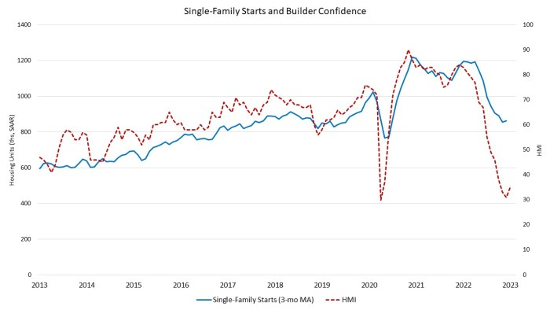
Total housing starts for 2022 were 1.55 million, a 3% decline from the 1.60 million total from 2021. Single-family starts in 2022 totaled 1.01 million, down 10.6% from the previous year. Multifamily starts (2+) in 2022 were up 15.1% compared to the previous year and exceeded a 500,000 annual pace for the first time since the Great Recession.

On a regional and year-to-year basis, combined single-family and multifamily starts are 5% higher in the Northeast, 5.7% lower in the Midwest, 1.6% lower in the South and 7.2% lower in the West.

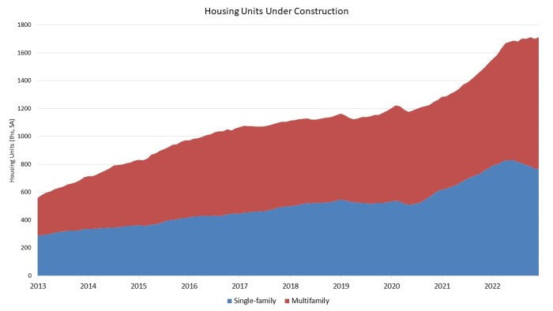
As an indicator of the economic impact of housing, there are now 769,000 single-family homes under construction. This is 0.1% lower than a year ago. There are currently 943,000 apartments under construction, up 24.9% compared to a year ago (755,000). Total housing units now under construction (single-family and multifamily combined) is 12.3% higher than a year ago.

Overall permits decreased 1.6% to a 1.33 million unit annualized rate in December and are down 29.9% compared to December 2021. Single-family permits decreased 6.5% to a 730,000 unit rate and are down 34.7% compared to December 2021. Multifamily permits increased 5.3% to a 600,000 unit pace.

Total permits for 2022 were 1.65 million units, a 5% decline from the 1.74 million unit total from 2021. Single-family permits in 2022 totaled 972,000 unit rate, down 12.9% from the previous year. Multifamily permits in 2022 were up 9.0% compared to the previous year.

Looking at regional permit data on a year-to-year basis, permits are 13.6% lower in the Northeast, 3.4% lower in the Midwest, 2.4% lower in the South and 8.3% lower in the West.

