Advocacy Digest | May 21, 2021
Brad Boycks, Executive Director

Uniform Dwelling Code Council (UDC Council)
Recently the UDC Council met for the first time since December of 2019 to elect new leadership and discuss a possible move from the UDC to the IRC as the base code of one- and two-family home construction in Wisconsin.

We still have three WBA members serving on the UDC Council; Abe Degnan, Mark Etrheim, and Dawn McIntosh, and one former member, Dan Wald, out of the nine total members. There are also two inspectors who were appointed by Gov. Walker that have worked well with our members on the council; Brian Wert and Scott Satula.

Brian Wert was elected chair of the council and Mark Etrheim was elected vice chair. This was a very positive result and Mark will have some influence on future agendas and the direction that the committee takes.

The council observed a presentation from a government affairs official from the ICC on why Wisconsin should move to the IRC as the base code in Wisconsin. The prep work that was done leading up to the meeting to establish talking points and real-world examples of why the move to the IRC was well worth the time. Mark and Abe did an excellent job of pushing back against a move to the IRC and other members of the council, most notably Dan Wald, Brian Wert, and Scott Satula, advocated for a slow pace to further discuss and review any changes to the UDC and to compare any changes to the IRC.

Bob DuPont, a former DSPS employee, also made a presentation and submitted documents that advocated for the switch from the IRC to the UDC for the base code in Wisconsin.

Ultimately, a motion was passed to table this discussion to a future meeting and to study the difference between the IRC and UDC.

With Mark’s election and no motion passed to move from the UDC to the IRC for the base code in Wisconsin, the results of the first UDC Council meeting in 16 months were positive. On word of caution, the push to move to the IRC, or to incorporate provision of the IRC to the UDC (most notably on the energy code side) will be something that our members will have to push back on during every future meeting of the council. We will continue to work together to make sure we have a coordinated effort on this topic.

The meeting was adjourned with no discussion of when a future meeting will take place. When the goal is no big changes to the code the fact that there does not seem to be a big push to meet again soon is a positive sign.

Workforce Housing options in Wisconsin
The topic of providing more workforce housing options in Wisconsin is being talked about by members of the Wisconsin Legislature on both sides of the political aisle. Recently, WBA staff has been meeting with legislative leaders to provide a summary of items related to workforce housing that have been introduced and provide some options for provisions in other states. Those items are listed below for your review.

2021 State Budget Provisions
Tax Incremental Housing for Workforce Housing (recently removed from the state budget)
- 2021 AB 68, summary on pages 134-135
- LRB Analysis of 2021-2021 Executive Budget Bill pages 136-137
- This provision was also part of 2019 AB 859/SB 811 by Brooks and Feyen
First-Time Homebuyer Savings Accounts
- 2021 AB 68, summary on page 174
- LRB Analysis of 2021-2021 Executive Budget Bill page 178

2019-2020 Bills
Sales Tax Exemption for Materials Used to Construct Workforce Housing; SB 791
- Creates a sales and use tax exemption for the sale of building materials, supplies, equipment, landscaping, and lawn maintenance services if the property or service is acquired solely for, or used solely in, the construction or development of a workforce housing development.
- Residential units are intended for initial occupancy by households whose income is at least 60 percent, but not more than 120 percent, of the county's median household income.

Creating Refundable Individual Income Tax Credit for Rehabilitation Expenses; SB 792/AB 905
- A refundable individual income tax credit of 10 percent of the amount spent by the claimant on qualified rehabilitation expenditures on a construction or reconstruction project on eligible housing.
- Initial construction of the residence was completed before 1980 and the fair market value of the residence is equal to or less than the median price of a single-family residence located in the same county.
- The maximum credit amount is $15,000 per claimant, which is 10 percent of up to $150,000 spent on qualified rehabilitation expenditures.
- Homeowners could claim as much as $138 million annually in older housing rehabilitation credits

Proposals in other states
Michigan: Employer Support of Workforce Housing Tax Credit; Michigan SB 360
- Employers can claim an income tax credit equal to 50% of the total eligible contributions made during the tax year. Eligible contributions include:
  - Supporting a local impact housing trust fund
  - Offering employees the option to participate in a qualified employer-assisted housing project that assists employees in securing affordable housing near the workplace
  - A “project” is down-payment assistance, reduced-interest mortgages, mortgage guarantee programs, rental subsidies, individual development account savings plans, or any other similar type of project approved by MI State Housing Development Authority (MSHDA).
  - These contributions are only eligible for employees whose adjusted household income is not more than 120% of the area median income as determined by MSHDA.

New Jersey: American Dream Act; New Jersey SB 242
- The grant program would provide down payment assistance and home repair assistance to certain low and moderate income, first-time homebuyers to defray the costs associated with acquiring and rehabilitating single-family housing for principal residence.
- Under the grant program, the maximum grant awarded to each first-time homebuyer would not exceed six percent of the home’s purchase price or $10,000, whichever is greater.
Suggestion: if this were used as a guide, target only workforce housing units

Reducing the Cost of Housing Infrastructure
- WHEDA CEO Joaquín J. Altoro recently mentioned one of the biggest challenges to workforce housing development was the cost of infrastructure (sewer, water, sidewalks) that a developer pays for and dedicates to a municipality.

A grant program could be developed to help municipalities to pay for infrastructure for developments that contain at least 60% workforce housing units to help drive down the cost of development.

You could use the definition of “property for public use” with the same definition used in 2019 SB 791: includes sidewalks, wastewater collection and treatment systems, drinking water systems, storm sewers, utility extensions, telecommunications infrastructure, streets, roads, bridges, and parking ramps.

- Create mandates or incentives for municipalities to lower the minimum lot sizes for new developments and reduce the widths of streets, sidewalks, and setbacks.

From NAHB: Gains for Single-Family Built-for-Rent Ahead?
BY ROBERT DIETZ on MAY 19, 2021
Counter to expectations, the number of single-family homes built-for-rent (SFBFR) construction starts posted a year-over-year decline for the first quarter of 2021. The SFBFR market is a way to add single-family inventory amid concerns over housing affordability and downpayment requirements in the for-sale market, particularly during a period when people want more space and a single-family structure. Single-family built-for-rent construction differs with respect to structural characteristics compared to other newly-built single-family homes, particularly with respect to home size.

According to NAHB’s analysis of data from the Census Bureau’s Quarterly Starts and Completions by Purpose and Design, there were approximately 7,000 single-family built-for-rent starts during the fourth quarter of 2020. This was a 22% decline relative to the first quarter 2020 total of 9,000. Over the last four quarters, 42,000 such homes began construction, which is about flat compared to the 41,000 estimated SFBFR starts for the four prior quarters.
Given the small size of this market segment, the quarter-to-quarter movements typically are not statistically significant. The current four-quarter moving average of market share (4.1%) remains higher than the historical average of 2.7% (1992-2012) but is down from the 5.8% reading registered at the start of 2013.
Importantly, as measured for this analysis, this class of single-family construction excludes homes that are sold to another party for rental purposes, which NAHB estimates may represent another two percent of single-family starts. The estimates in this post only include homes built and held by the builder for rental purposes. It is possible this share is rising, and we will have future survey results to explore it.
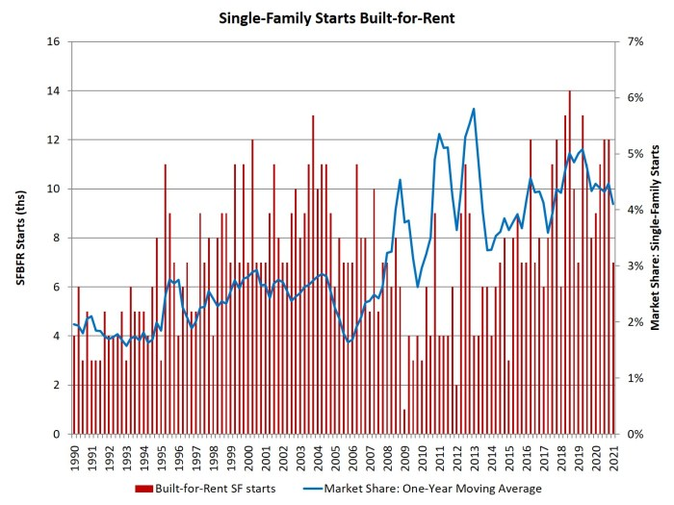
With the onset of the Great Recession and declines in the homeownership rate, the share of built-for-rent homes increased in the years after the recession. While the market share of SFBFR homes is small, it has been trending higher. As more households seek lower density neighborhoods and single-family residences, but some must do so from the perspective of renting, the SFBFR market will likely expand in the quarters ahead as the economy recovers from the virus crisis.

